THE UNITED CHURCH OF CHRIST

(Congregational)

13740 Pearl Road Strongsville, Ohio 44136

(440) 238-6697

StrongsvilleUCC@gmail.com
StrongsvilleUCC.com

Rev. Heidi Denman McDougall, Pastor

Sunday, April 19, 2026– 10 A.M.
Sacrament of Holy Baptism
------------------------------------------------------------------------------------
WELCOME!
We are grateful you chose to worship with us this morning. No matter who you are or where you are on life’s journey, you are welcome here.
_________________________________________________________________

† Please stand as you are comfortable.

BELL PRELUDE “The Strife is O’er” arr. Wagner

WELCOME AND ANNOUNCEMENTS Irene Joyce

BELL INTROIT “As the Deer” Nystrom arr. Bettcher

† CALL TO WORSHIP
Leader: Lift your voices to God.
People: We call on the One who promises to hear us.
Leader: In life, in death, in every moment, God deals graciously with us.
People: We rejoice in the One who saves us.
Leader: We will break the Bread of life in thanksgiving to God.
People: We will lift up the Cup of salvation, drinking deeply from it.

† HYMN 225 “Come, Christians, Join to Sing”

A READING FROM THE PSALMS Psalm 116: 1-4, 12-19
(New International Version)
I love the Lord, for he heard my voice; he heard my cry for mercy.
Because he turned his ear to me, I will call on him as long as I live.
The cords of death entangled me, the anguish of the grave came over me;
I was overcome by distress and sorrow.
Then I called on the name of the Lord: “Lord, save me!”
What shall I return to the Lord for all his goodness to me?
I will lift up the cup of salvation and call on the name of the Lord.
I will fulfill my vows to the Lord in the presence of all his people.
Precious in the sight of the Lord is the death of his faithful servants.
Truly I am your servant, Lord; I serve you just as my ancestors did;
you have freed me from my chains.
I will sacrifice a thank offering to you and call on the name of the Lord.
I will fulfill my vows to the Lord in the presence of all his people,
in the courts of the house of the Lord— in your midst, Jerusalem.
Praise the Lord!

Leader: The Word of God, for us, the people of God;
People: Thanks be to God.

SHARING JOYS AND CONCERNS

PRAYER

THE LORD’S PRAYER (in unison)
Our Father, who art in heaven, hallowed be Thy name. Thy kingdom come. Thy will be done on earth as it is in heaven. Give us this day our daily bread. And forgive us our debts, as we forgive our debtors. And lead us not into temptation, but deliver us from evil. For Thine is the kingdom, and the power, and the glory, forever. Amen.
BELL ANTHEM “Adagio” Albinoni, arr. Hopson

CHILDREN’S MESSAGE


THE SACRAMENT OF BAPTISM

Adeline Eleanore Erdman
Daughter of Sarah and Erik Erdman
Sponsors: Patrick Sponsler and Sami Sponsler

WELCOME AND INTRODUCTORY WORDS

QUESTIONS AND RESPONSES FOR THE FAMILY

CONGREGATIONAL PROMISE
Jesus Christ calls us to make disciples of all nations and to offer them the gift of grace in baptism. Do you, who witness and celebrate this sacrament, promise your love, support, and care to Adeline and her family, as she lives and grows in Christ?
(We promise our love, support and care.)

PRAYER OF BAPTISM
Christ be with you. (And also with you.) Let us pray.
Gracious God, bless this water by your Holy Spirit. By that same Spirit, save those who confess the name of Jesus Christ, that sin may have no power over them. Create new life in the child baptized this morning, that she may rise in Christ. All glory and honor be to you, Eternal God, who was, who is, and shall always be, world without end. Amen.

BAPTISM OF ADELINE ELEANORE ERDMAN

CONGREGATIONAL PRAYER
Let us pray together:
Gracious God, You have filled the world with joy with the gift of Jesus. Bless this child, Adeline Eleanore; fill her with your strength and courage for life’s journey; joy for all to see; freedom of love; hope for a new life. May she never be ashamed to confess her personal faith in You. Bless us, O God, that we, too, may be faithful to Your Word, united in the peace of Christ and the company of the Holy Spirit. Amen.

HYMN “Child of Blessing, Child of Promise”
Child of blessing, child of promise, Baptized with the Spirit's sign;
With this water God has sealed you Unto love and grace divine.

Child of love, our love's expression, Love's creation, loved indeed
Fresh from God, refresh our spirits; Into joy and laughter lead.

Child of joy, our dearest treasure, God's you are; from God you came.
Back to God we humbly give you; Live as one who bears Christ's name.

Child of God, your loving Parent, Learn to know whose child you are.
Grow to laugh and sing and worship; Trust and love God more than all.

OFFERING

OFFERTORY “It is Well with My Soul” Bliss

† DOXOLOGY 815 Tune: Old Hundredth
Praise God from whom all blessings flow. Praise Him, all creatures here below.
Praise Him above, ye heav’nly host. Praise Father, Son and Holy Ghost. Amen.

† DEDICATING OUR LIVES AND OUR GIFTS

A READING FROM THE GOSPELS Luke 24: 13-35
(The Message)
That same day two of them were walking to the village Emmaus, about seven miles out of Jerusalem. They were deep in conversation, going over all these things that had happened. In the middle of their talk and questions, Jesus came up and walked along with them. But they were not able to recognize who he was.

REFLECTION “On the Road Again”

† HYMN 424 “The Servant Song”

† BENEDICTION Nathan Nettleton
Go now as witnesses of God’s eternal presence. May the risen Christ make himself known to you in the breaking of bread; set your faith and hope on God, fulfilling your vows and living in genuine mutual love. And may God hear and respond whenever you call; may Christ Jesus make himself known to you in all things; and may the Holy Spirit open your eyes and set your hearts on fire with love. Go in peace to love and serve the Lord, in the name of Christ. Amen.

† POSTLUDE “Hornpipe” Handel
===============================================================
PLEASE NOTE: Our worship services are video recorded each week and posted on our YouTube channel for all to enjoy. Just go to strongsvilleucc.com, select Worship, and click on Service Videos.
====================================================
SERVING
TODAY – APRIL 19 NEXT SUNDAY – APRIL 26
Barbara & John Toth Greeters Judi Pavisich
Sandy O’Shea Liturgist Dale Hawk
Teri Barbish Head Usher Carole Kapcar
Tom Foley Director of Music Tom Foley
Mike Elkins Associate Director of Music Mike Elkins
Sharon Heinrich Organist Sharon Heinrich
Doug Thorn/Jim Heinrich Video/Sound Doug Thorn/Jim Heinrich
Bell Choir Special Music Chancel Choir
----------------------------------------------------------------------------------------------------

A NOTE OF THANKS—We thank our Bell Choir (with special guest substitute ringer, Robert Foley), Mike Elkins, Tom Foley, and Sharon Heinrich for their music this morning!
=========================================================
Our steeple will light the sky this week—
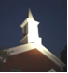
Happy Birthday to Evan Joyce on April 20th
and to Irene Jannsohn on April 24th!
In loving memory of Aimée Jannsohn
Love, The Dicksons & Joyces
Happy Anniversary April 21st to Rachel & Gary Zielinski!

Happy Birthday today to Devin Thorn!
====================================================
FROM THE SUNDAY SCHOOL:
PENNY SUNDAY IS NEXT WEEK--Please bring your coins, dollars, and checks to UCC on April 26th for Penny Sunday. The money will go to the Northeast Ohio Collie Rescue and we will have a special visitor.
==============================================

OFFERINGS RECEIVED

Weekly Offering Needed $ 4,359.00
Last Week’s Offering Received $ 7,353.00
Difference + $ 2,141.00
Thank you very much for your support.
PLEDGES RECEIVED: 62

Join us for the Diaconate’s Food, Friends, and Fun-Draiser!
Friday, May 1st at Grindstone Tap House—SIGN UP WITH YOUR basket ideas!
TICKETS ARE $30 and are ON SALE NOW!
------------------------------------------------------------------------------------

MISSION OUTREACH NEWS:
We are collecting new items for Laura’s Home (Feminine pads with wings, baby wipes, Size 6 and 7 diapers or Pull-Ups, and Pedialyte) through Mother’s Day. We will have a bin in the Gathering Area for your donations. As an alternative, you can purchase Amazon gift cards—available through our Gift Card program. See Jim Joyce or contact the church office to purchase (double benefit)!
==============================================

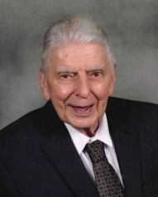
Long-time member of the church Elroy (Roy) Merkle passed away peacefully on April 15, 2026 at the age of 94. Our love and prayers go out to his wife of 20 years, Carol Merkle, as well as his children, Lori Groose and Dave Merkle, and step-daughter, Sandy Pogozelski (Bob) and family. Roy, a proud Navy veteran, was a faithful member of our congregation for 42 years. A memorial service was held at Chambers Funeral Home yesterday.
====================================================
OUR PRAYER LIST

Please provide updates for this list to the church office.

Long-Term Care or Homebound: Irene Jannsohn, Connie Rebar

Church Family: Serena Abruzzino, Jen Barry, Mark Camp, Judy Carte, Elaine Cofffey, Betty “Grammy” Craig, Sam Cuyler Jr., Roger Davis, Colette Emerson, Roz Fotos, Sue Hawk, Frank Jefferis, Pam & Bruce Keenen, Erv Koch, Jill Kundtz, Jan Meier, Carol Konet, Bobbie & Wayne Krisak, Karl & Sharon Kuhlenschmidt, Jim Maresco, Jan Meier, Amanda Moulton, Ginny & Kenn Oerkfitz, George & Joyce Reed, Dorothy Ritchie, Ron Rothel, Jennifer Sekorky, Tracy Seneff, Peter Smith, Bruce Sperber, Linda Stepan, JoAnn Thomas, Debbie Wentz, Heather Williams, Claire Wills, Marty Winch

Extended Church Family: Barbara Davis (Don & Sandy Gleichauf’s friend), Allison Emerson (Colette’s sister), Kim Filiatraut (Sarah Keenen’s friend), Elizabeth Fulford (Lora Rung’s friend), Joanne Gariepy (Sally Herzog’s friend), Kathy Ghetti (friend of Ginger Rothel), Jennifer Gleichauf (Don & Sandy’s daughter-in-law), Sarah & David Gleichauf (Don & Sandy’s grandson & wife), Michaelene Hanrahan (Jim Joyce’s sister), Dana Hardy (Craig’s wife), Tiffany Hassel (Judi Pavisich’s daughter-in-law), Barb & Dale Holmberg (Tiffany Hassel’s parents), Maryanne Grega-Knotek (our florist), Helen Leckwatch (Dale Parson’s mother-in-law), George Love (friend of the church), Diane Mason (Lora Rung’s friend), Linda McNabb (Ginger Rothel’s sister-in-law), Sylvia Pakish (Don & Sandy Gleichauf’s friend), Jeff Peacock (former member), Amanda Shannon (Sarah & Jon Hayes’ friend), Vicki Smith (Venner Clarinets), Jeaneane Steinmeyer (Greg Dickson’s aunt), Don & Pauline Wills (Judi Pavisich’s friends), the people of Ukraine, Sudan, Gaza, and Israel, victims of violence and natural disasters, First Responders

OPT-IN: Please contact Pastor Heidi if you would like to pray for others via the email prayer chain. h.e.denman@gmail.com
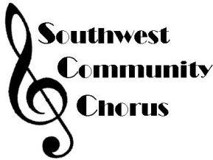
FROM OUR FRIENDS AT
SOUTHWEST COMMUNITY CHORUS
SWCC will have a Spring Concert, “Celebrate America” on Sunday, May 3rd at 3 p.m. at the Berea United Methodist Church (170 Seminary Street in Berea). The Chorus is under the direction of Tom Foley, accompanied by Jarred Sorauf; some of the singers this season include Craig Hardy, Ingrid Dickson, Irene Joyce, Sarah Keenen, Marianne Luca, Jo Ann Thomas, Dave Williams and a few other familiar faces and voices. Tickets are $15 will be available at the door or from our own choir members who sing with the chorus.
--------------------------------------------------------------------------------------

FROM OUR FRIENDS AT ST. JOSEPH CATHOLIC CHURCH:
St. Joseph’s church (12700 Pearl Road) will be hosting an Ecumenical Taizé Prayer Service for Peace on Sunday, April 26th at 7 p.m. Come join our brothers and sisters in Christ as we pray for peace in the world. We will come together for a time of meditation, singing, and reflection, in gratitude for God’s presence and love in our hearts and lives. There will be a small social following the service.
====================================================BOOK STUDY!
Tomorrow, April 20th at 7 p.m., Our Book Study will continue. All are welcome to join us!
===================================

THREE WITH GLEE!
Capital Campaign: We currently have $ 62,212.08 in our capital campaign account. We are getting additional bids for the acoustic panels in Pilgrim Hall. A new roof for Pilgrim Hall and the church building may be on the horizon. Things are happening, but we still have more projects on the list. Please make sure you designate your donation for “Capital Campaign.” Thanks for your continuing support.
====================================================
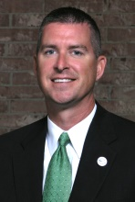
DR. CAMERON RYBA, SUPERINTENDENT OF STRONGSVILLE SCHOOL DISTRICT
WILL BE ANSWERING QUESTIONS ABOUT THE DISTRICT TODAY IN PILGRIM HALL FOLLOWING OUR WORSHIP SERVICE.
----------------------------------------------------------------------------------------
WOMEN’S FELLOWSHIP—

Members of Women's Fellowship made and sold 92 bags of “People Chow.” Income from the sale of the 92 bags and leftover ingredients totaled $405.50. Expenses totaled $98.62. The profit from the sale was $306.88.

A big thank you to all who helped make the “People Chow” and to those who purchased it!


GRADUATES

Our church would like to recognize our graduates, so please let us know if someone is graduating within your family. Send the following information and a PHOTO of your high school, college, or tech graduate.

Name of graduate (include middle name):

____________________________________________________________

Graduate’s address:____________________________________________

____________________________________________________________

____________________________________________________________

School: _____________________________________________________

Graduation Date (month at least):__________________

Church Family member:
____________________________________________________________

Relationship to church member: __________________________________

Activities: ___________________________________________________

____________________________________________________________

Honors and Awards: ____________________________________________________________

____________________________________________________________

Diploma / Degree Earned: ____________________________________________________________

Future Plans: ________________________________________________

____________________________________________________________

Parents/Grandparents: ____________________________________________________________

____________________________________________________________

Please email the above information, along with a photo of the graduate, to the church office at strongsvilleucc@gmail.com by Sunday, May 24th.

====================================================

UPCOMING BOARD MEETINGS
- The Diaconate will meet on the third Tuesday of the month, April 21st at 10:30 a.m. in the Parlor.
- The Official Board will meet on the fourth Tuesday of the month, April 28th at 7 p.m. in the Parlor.
==============================================
A great big THANK YOU to everyone who participated in our Annual Family Game Gathering yesterday! A great time was had by all!
CHURCH OFFICERS 2026

*Elected February 1, 2026

Moderator: Rachel Zielinski *
Vice-Moderator: Herb Hampson*
Treasurer: Sally Herzog* Clerk: Judy Gaumer*

Sunday School Superintendent: Linda Elkins

Board of Trustees
Karen Bates Jen Barry* Greg Dickson*
Bill Giuliano* Chris Goff Les Fox* Cathy Hawk
Sandy Pogozelski* Bill Robinson * Cheryl Sobek
Alex Tomoff Mike Willis

Endowment Fund Subcommittee
Linda Stepan* Dave Williams*

Diaconate
Jean Bittinger Elaine Coffey* Diana Creecy*
Bobbi Cook Wayne Cook Judy Davis
Judy Fox* Pam Heimburger Marsha Hemphill*
Cindy Hurley* Lynne McCray*
Linda Ponstingle Lora Rung

Christian Education Committee
Linda Elkins* Colette Emerson* Dale Hawk
Sarah Hayes Amanda Marshall* Lora Rung

Music Committee
Karen Bates* Ingrid Dickson*
Pam Keenen Ken Mehalko Mike Willis
ex officio: Sharon Heinrich Tom Foley Mike Elkins

Stewardship Committee
Ingrid Dickson Sue Gigliotti* Linda Stepan
Rob Toth* Sarah Toth Dave Williams

Mission and Outreach Committee
Jen Barry * Gina Cathcart Bobbi Cook*
Cathy Hawk Sarah Hayes* Lora Rung
Mary Willis Mary Ellen Zimmerman
-----------------------------------------------------------------------------------
THERE’S STILL TIME TO PLEDGE FROM YOUR H.E.A.R.T.!
Hospitality, Engagement, Activities, Resources, Time, Talent, & Treasure
----------------------------------------------------------------------------
United Church of Christ 2026 Estimate of Giving

In recognition of God's many blessings to me, I am happy to join with others in the following commitment for 2026:

Name ____________________________________________

Address __________________________________________

I plan to give $___________ each

 week  month  other ____________ to be used for

Our Congregation's Ministries and Operations $___________

Our Church's Wider Mission (OCWM) $___________

 I would like to talk with someone from the Endowment Committee about including the church or church-related institution in my Will.

 I would like to talk with someone about using the automatic deduction plan from my checking/savings account.

Signed _______________________________________ Date ____/____/____

For where your treasure is, there will your heart be also. Matthew 6:21
===================================================


FREE LUNCH FOR ALL--Wednesdays
11:30 a.m.-12:30 p.m.
A reminder: Donations are welcomed to support the increasing costs of this valuable program. Thank you to all of our faithful volunteers!
=========================================================

THRIFT SHOP
The Thrift Shop is OPEN on Thursdays from 10 a.m. until 4 p.m. Come and shop lots of interesting merchandise at amazing prices. Donations are accepted during our Thursday sale hours, but please try to limit your donations to what you can carry downstairs. Please do not abandon items outside the church doors.
----------------------------------------------------------------------
YOUTH GROUP NEWS
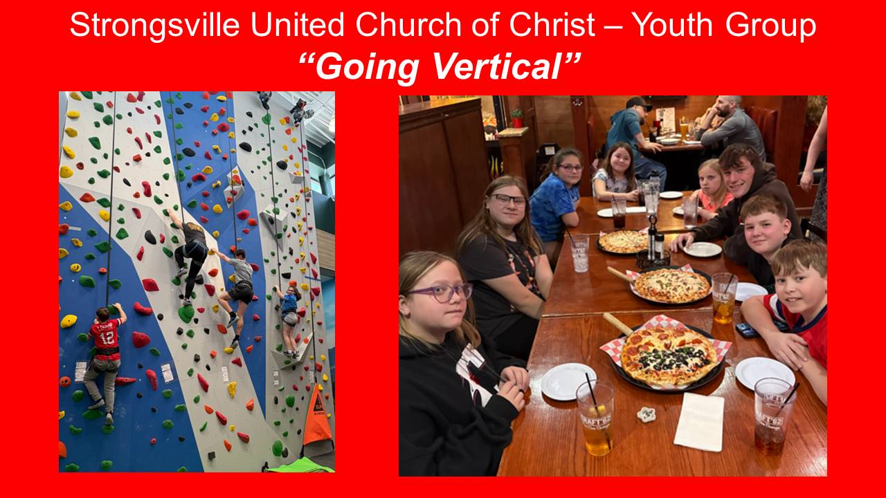
On April 12th, our Youth Group kids had a fantastic time going rock climbing at Dick’s Sporting Goods, followed by pizza at Gino’s Restaurant. Thanks to everyone who made our outing so much fun!
===================================================

IMPORTANT INFO—Do you know where the AED and First Aid Kit are located in the church? They are adjacent to the doorway in Pilgrim Hall, just to the right of the confirmation classroom.
------------------------------------------------------------------------------------------


WE NEED YOUR HELP!
If you are the last or almost the last person to leave the church building on any given day, please make certain that all the lights are off and most importantly, that the door to the kitchen and the parking lot doors are locked and PUSHED SHUT so the lock is latched. The Board of Trustees is addressing this issue, but in the meantime, it’s all hands on deck to keep our church building secure. Thanks in advance for your diligence!
=======================================================

YES! I’D LIKE TO BE PART OF OUR CHURCH FAMILY CARE TEAM.

NAME_________________________________

PHONE _______________________________

EMAIL_________________________________

I AM INTERESTED IN:

______ OFFERING OR RECEIVING COMMUNION AT HOME

_______CALLING FOLKS WHO WOULD LIKE TO JOIN PRAYER CHAIN, BUT DON'T USE EMAIL

_______ PREPARING AN EXTRA MEAL AND DELIVERING IT TO SOMEONE WHO’S HOMEBOUND

______ HELPING COOK A DISH AND OR SERVE MEALS AT FUNERAL LUNCHEON

______ BECOMING A “PHONE BUDDY” AND PERIODICALLY CHECK IN WITH SOMEONE WHO’S HOMEBOUND

______ OFFERING AN OCCASIONAL RIDE TO TAKE MEMBERS TO APPOINTMENTS

______ OFFERING AN OCCASIONAL RIDE TO OUR CHURCH SERVICES

_______BE PART OF A CARD CREW TO SEND CARDS TO FOLKS ON HEIDI’S PRAYER LIST AND OUR HOMEBOUND MEMBERS

______ I WOULD BE WILLING TO…

